 | Air University, Islamabad
Project Proposal
for
NexusID

Version 3.0
By
Khuzaifa Baseer 232061
Hussain Abdullah 231999
Safi Ur Rehman 231987


Supervisor
Ms. Seemab Khan

Bachelor of Science in Software Engineering (2023-2027)

Revision History

Version | Date | Feedback | Action Taken
2.0 | 6th May, 2026 | 1. SD-JWT, RSA, SHA-256 mentioned but workflow not clearly explained, too theoretical  2. Key management not discussed (storage and protection missing)  3. Security risks incomplete (only replay attack mentioned, others missing)  4. Backend role unclear, trust assumption not properly justified  5. System diagram missing  6. Mockups missing captions  7. Section 4 not properly structured into application, methodology, strength, weakness  8. References contain unnecessary subheadings | 1. Added Section 3.2 explaining workflow clearly  2. Added Section 8.1 covering key management and protection  3. Added Section 8.2 expanding security risk analysis  4. Added Section 3.3 clarifying backend role and trust model  5. Inserted context diagram in Section 6  6. Added captions in Section 14 for all mockups  7. Reorganized Section 4 into structured columns (application, methodology, strength, weakness)  8. Cleaned up references by removing subheadings
3.0 | 15th July, 2026 | Evaluator 1: The project scope is limited. This does not qualify as an FYP project. It is suggested to increase the scope  Evaluator 2: Problem is very precise and limited. Scope is limited, needs improvement. | 1. Expanded the project scope through the addition of new functionalities  2. Added Section 7.3 (Web Portal), a role-based module serving both Users and Service Providers  3. Implemented credential revocation as a functioning feature, supported by a dedicated revocation registry  4. Introduced multi-issuer support through a registry of issuer public keys, replacing the single hardcoded Mock Issuer  5. Expanded the number of modules, while also updating existing modules to support the newly added functionality  6. Increased the number of mockups, and revised all sections to maintain consistency with the newly added functionalities.
Table of Contents
Abstract 1
1. Introduction 2
2. Problem Statement 2
3. Problem Solution 3
3.1 Objectives 3
3.2 Cryptographic Workflow 4
3.3 The Trust Model 4
4. Related System Analysis 5
5. Vision Statement 5
6. Scope 5
7. Modules 7
7.1 Client Mobile App 7
7.2 Chrome Extension 8
7.3 Web Portal 8
8. System Limitations and Constraints 9
8.1 Key Management and Storage 9
8.2 Security Risk Analysis 10
9. Data Gathering Approach 11
10. Tools and Technologies 12
11. Project Stakeholders and Roles 12
12. Module based Work Division 13
13. WBS and Gantt Chart 14
14. Mockups 16
15. References 23
16. Plagiarism Report 24

Project Category:
A-Desktop Application/Information System B-Web Application/Web Application based Information System C-Problem Solving and Artificial Intelligence D-Simulation and Modeling E-Smartphone Application
F-Smartphone Game G-Networks H-Image Processing
Other (specify category) ________________

Abstract
With increasing reliance on digital platforms for everyday services, there is a growing need for identity verification systems that respect user privacy rather than compromising it. Currently, most online platforms require users to submit complete personal records including national IDs, employment details, and academic credentials, even when only a single attribute needs to be confirmed. This over-collection of data not only puts users at risk of data breaches and identity theft but also burdens service providers with storing large volumes of sensitive data they do not actually need. While some modern tools like social logins and autofill managers improve convenience, they still do not address the underlying privacy concern. The gap lies in the absence of a practical, everyday tool that acts as a shield between users and the platforms demanding their data. NexusID will address this problem, by introducing a mobile application that acts as a secure wallet for digitally signed credentials and generates cryptographic proofs in response to verification requests, ensuring that platforms receive only a confirmation of eligibility rather than the actual personal data. A Chrome browser extension will serve as the authenticator, detecting verification requests on websites and triggering approval notifications on the user’s mobile device, while a supporting web portal will allow users to manage their devices and service providers to configure their verification needs. Together these components will form a bridge between users and online services, allowing a platform to confirm that a user meets a required condition such as nationality or employment status without ever accessing the actual data behind that claim. By shifting control of personal data back to the user, NexusID will also reduce unnecessary data accumulation on the databases of service providers, addressing the problem from both sides.

Introduction
The purpose of this proposal is to present NexusID, a privacy-preserving identity verification system that will give users direct control over what personal information they share with online platforms. As digital platforms have become a routine part of daily life, identity verification has emerged as a standard requirement across websites, applications, and digital portals. The common practice today involves collecting complete personal records from users during registration or access requests, often gathering far more information than the platform actually needs. A practical example is employment verification, where a platform asks for a full work history when it only needs to confirm that a user is currently employed. The same issue arises with medical eligibility checks, where a service demands complete health records simply to confirm that a basic condition is met. This pattern of over-collection creates serious privacy risks, as large volumes of sensitive data stored across multiple platforms become attractive targets for cyberattacks and breaches.
Current tools such as social logins, password managers, and autofill extensions make the process faster and more convenient but do not reduce how much raw data is transmitted to third parties. Users have no way of limiting what is shared or knowing how their data is stored and used after submission. Therefore, there is a clear need for a system that sits between the user and the requesting platform, acting as a shield that allows eligibility to be confirmed without personal data ever changing hands. NexusID is proposed as a solution to this problem, built on modern cryptographic standards that will make selective and privacy-respecting verification both technically achievable and practically usable.

Problem Statement
The way personal data is collected and stored across the internet today creates risks that extend well beyond any single website or service. Whenever a user registers for a service, submits an application, or completes a verification step, a portion of their personal information is copied into that platform’s database and remains there indefinitely. Because there is no practical way for users to know how many databases hold copies of their information, or to revoke access once it has been granted, users effectively lose control over their data the moment it is submitted. This is compounded by the sheer number of platforms an individual interacts with over time, from academic institutions to healthcare providers to employers, with each one becoming a separate point of failure. When any of these databases suffers a breach, users face consequences ranging from identity theft to financial fraud. Service providers are not spared either, as storing sensitive personal information places them under growing storage costs and legal compliance obligations, requiring them to secure data they did not strictly need to collect in the first place.

A specific and recurring instance of this broader problem occurs during identity verification, where platforms request complete personal records to confirm a single condition. A ride-sharing platform verifying a driving license, a scholarship portal confirming a minimum CGPA, or an online retailer checking legal age all currently require the user to disclose far more information than the platform actually needs to complete that one check. NexusID will focus on addressing this particular instance of the larger problem, using selective disclosure to allow users to prove that a specific condition is met without exposing the personal record behind it. NexusID will aim to demonstrate that the systemic issue of data over-collection can be resolved through cryptographic attribute verification, offering a foundation that could extend to broader identity and data-sharing scenarios in the future.

Problem Solution
NexusID will provide users with a practical and user-centered mechanism to respond to identity verification requests without submitting their full personal data to online platforms. The system will be built around a React Native mobile application that will serve as the user’s personal credential wallet, storing identity data securely on the user’s device. When a website requires verification, NexusID Chrome browser extension will detect the request, extract a unique challenge nonce from the verifier, and send a push notification to the user’s mobile application. The user will be shown exactly what information is being requested and will have the option to approve or decline before anything is transmitted. Upon approval, the mobile application will generate a cryptographic proof using SD-JWT, SHA-256 hashing, and RSA public key cryptography, confirming whether the requested condition is satisfied without revealing the data behind it. The website will receive only this proof, never the actual personal data behind it.

A role-based web portal will support this flow on both sides of the interaction. Service providers will use it to register, configure their verification requirements, and monitor their verification activity. Users will use it to sign in via QR code, manage their paired devices, and recover access if their phone is lost. To support this recovery process and to allow issued credentials to be invalidated when necessary, the backend will maintain a revocation registry that verifiers will check before accepting a proof. The backend will also maintain a registry of issuer public keys rather than a single hardcoded key, allowing credentials to originate from more than one type of trusted issuer, such as a government-style Mock Issuer for national identity attributes and a university issuer for academic attributes. Together, these components will give users direct control over what information they choose to disclose during online interactions, while giving service providers a reliable way to configure, receive, and verify the proofs they need.

Objectives
O-1: Develop a React Native mobile application that will allow users to store personal credentials securely and generate cryptographic proofs in response to verification requests.
O-2: Build a Chrome browser extension that will detect verification requests on websites and route them to the user’s mobile application as push notifications.
O-3: Implement SD-JWT based selective disclosure so that only the relevant attribute confirmation is shared with the requesting platform, keeping all other personal data private.
O-4: Ensure that no raw personal data is transmitted at any stage of the verification process, protecting users from data breaches and unauthorized access.
O-5: Develop a role-based web portal that will allow users to manage their account and paired devices, and allow service providers to configure verification requirements and monitor verification activity.
O-6: Implement a functioning credential revocation mechanism so that compromised or invalidated credentials can be rejected by verifiers before a proof is accepted.
O-7: Support multiple credential issuers through a public key registry, allowing NexusID to validate credentials originating from more than one trusted issuing authority.
O-8: Reduce unnecessary data accumulation on service provider databases by ensuring platforms receive only the minimum information required for a verification check.
O-9: Demonstrate that privacy-preserving identity verification is technically feasible and practically usable for everyday web interactions.

Cryptographic Workflow
NexusID will use SD-JWT combined with RSA and SHA-256 to create verifiable proofs without exposing personal data. Here is the practical workflow:
- Credential Issuance: When a user stores a credential such as nationality or academic standing, the relevant registered issuer, such as the Mock Issuer for national identity attributes or a university issuer for academic attributes, signs it using RSA private key cryptography, creating a digitally signed credential in SD-JWT format. This signed credential is stored on the mobile device and contains multiple claims (attributes) that can be selectively disclosed.

- Proof Generation: When a website requests verification for example to confirm driving license validity, the mobile app uses SD-JWT selective disclosure to extract only the relevant attribute from the credential. The proof will contain a confirmation statement such as “license requirement met” without revealing the underlying license details.

- Signing and Hashing: The selective disclosure proof is signed using the user’s RSA private key stored in Android Keystore to ensure it cannot be forged. SHA-256 hashing is applied to create a cryptographic fingerprint of the proof data. If even one character in the proof is altered during transmission, the hash verification will fail.

- Transmission and Verification: The signed and hashed proof is sent to the website through the backend server. Before forwarding the proof, the backend checks the revocation registry to confirm the credential and key have not been revoked. The website then verifies the proof by checking the RSA signature using the user’s public key and validating the SHA-256 hash to ensure the proof has not been tampered with.

The Trust Model
NexusID involves four participants: the credential issuer, the user, the backend server, and the service provider.
- Credential Issuer: Credentials will be issued by one of several trusted issuers registered in the system, such as the Mock Issuer for national identity attributes or a university issuer for academic attributes. Each issuer validates the relevant user attributes and signs credentials using its own RSA private key. The backend will maintain a registry of issuer public keys, allowing the system to verify credentials regardless of which issuer signed them.

- End User (Mobile Device): Stores credentials securely and generates selective disclosure proofs locally without transmitting raw personal data. The user’s private key is protected in Android Keystore.

- Backend Server: Acts as a trusted intermediary but does NOT access personal data. Its role is to route push notifications to the correct mobile device, store user public keys and the issuer public key registry, maintain the revocation registry and check it before forwarding a proof, store push tokens, maintain audit logs, and validate that service providers are authorized.

- Service Provider (Verifier): Sends verification requests to the user. Receives the proof generated by the user’s mobile device and verifies the signature using the user's public key, accepting the proof only if it is not flagged as revoked by the backend server.

- Trust Flow: The relevant issuer’s signature authenticates the credential, and the backend’s issuer registry confirms that signature came from a recognized issuer. The user’s signature on the proof authenticates the proof holder. The backend checks revocation status before forwarding the proof, and the service provider independently verifies the signature. The backend is trusted to route messages, maintain these registries, and check revocation status, but never handles personal data. If the backend is compromised, user privacy is preserved because it never had access to raw credentials.

Related System Analysis
Table 1: Related System Analysis with proposed project solution
Application Name | Methodology | Strength | Weakness
Sign in with Google/Facebook | Traditional OAuth-based authentication using third-party identity providers | Simplifies login process across platforms | Shares full user profile data with third-party platforms
LastPass/1Password | Password manager that stores and auto-fills credentials | Automates data entry | Automates data entry but still transmits full personal information to websites
Apple Wallet/Google Wallet | Digital wallet storing credentials and identity information | Convenient storage of credentials | Presents full credentials rather than selective proofs, controlled by platform ecosystems
W3C Verifiable Credentials | Decentralized identity model using verifiable credentials | Enables secure and verifiable digital identity | Limited user-friendly implementations for everyday web users

Vision Statement
For everyday internet users and online platforms who need a reliable and privacy-respecting way to handle identity verification, NexusID is a mobile and browser-based identity verification system that will allow users to store their personal credentials securely on their own device and manage their verification activity through a dedicated portal. Whenever a platform requests verification, users will receive a real-time approval notification and respond with a cryptographic proof that confirms eligibility conditions or credentials without revealing any personal data. Unlike existing solutions such as social logins, password managers and digital wallets that continue to transmit full personal records to third-party platforms, users of NexusID will retain complete control over their own data, share only what is strictly necessary, and protect themselves from the risks of data breaches and unauthorized data collection.

Scope
NexusID will be developed as a privacy-preserving identity verification system that allows users to confirm specific personal attributes to online platforms without handing over their full personal data. The system will revolve around three core components: a React Native mobile application, a Chrome browser extension, and a web portal, working together to handle the complete verification flow. The mobile application will act as the user’s personal credential wallet, storing digitally signed credentials covering attributes such as driving license validity, employment status, and academic standing. The Chrome browser extension will act as the authenticator on the web side, pairing with the mobile application through a QR code scan, detecting verification requests from websites, and routing them to the user’s mobile application. When a website requests verification, the extension will forward the request to the mobile app as a push notification. The user will see a clear summary of what is being requested and can either approve or decline before anything is shared. If approved, the mobile app will generate a cryptographic proof confirming whether the requested condition is satisfied and send it back to the platform. The platform will receive only this proof, meaning raw personal data will never be transmitted, only a cryptographically signed proof generated on the user’s device.
The web portal will serve both users and service providers through separate role-based dashboards accessed from a single application. Users will sign in via QR code and can manage their paired devices, view their verification history, and recover their account through re-issuance by the Credential Issuer if their phone is lost, which will also revoke the old key. Service providers will register with an email and password, configure their verification requirements, generate and rotate API keys for backend integration, and monitor their verification logs. A backend server will manage communication between the browser extension, the mobile application, and the web portal, and will maintain a revocation registry so that verifiers can reject proofs tied to invalidated credentials or revoked keys. The backend will also maintain a registry of issuer public keys, allowing credentials to be issued by more than one trusted authority, such as the Mock Issuer for national identity attributes and a university issuer for academic attributes. Communication between the extension and the mobile application will be handled through a secure messaging layer, which may include WebSocket connections or push notification services such as Firebase Cloud Messaging. The project will be built as a working prototype focused on web-based verification use cases. In this prototype, credential issuance will be simulated rather than connected to real government or institutional databases such as NADRA. While the current scope is limited to a prototype, the architecture will be designed to be modular and extendable toward larger identity systems in the future.

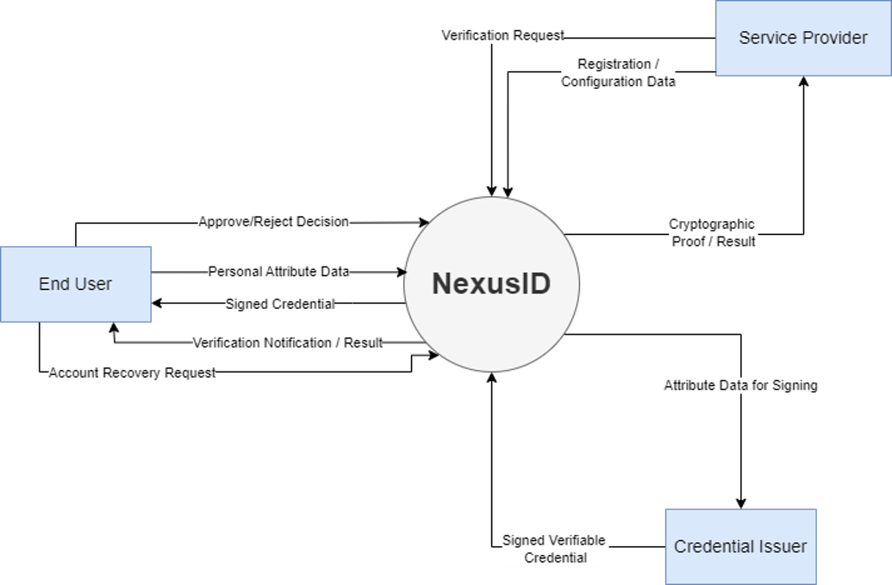
Fig. 6.1 - Context Diagram for NexusID

Modules

Client Mobile App
Module 1: User Onboarding and Profile Setup

- FE-1: Register a new account and set up a personal profile within the NexusID mobile application.
- FE-2: Pair mobile app with browser extension by scanning a unique QR code to link the device for secure notifications.
- FE-3: Enter personal attributes such as nationality, employment status, driving license validity, and medical eligibility. Data will be routed to the relevant registered issuer based on credential type, which signs the credential with its private key and returns a verifiable credential to the mobile app.
- FE-4: Upload and store national identity information securely within the application.
- FE-5: Edit and update personal profile information at any time.
Module 2: Credential Wallet

- FE-1: View all stored credentials and personal attributes in one place.
- FE-2: Add, update, and delete individual credentials as needed.
- FE-3: All stored credentials will be encrypted and protected from unauthorized access.
- FE-4: When a profile attribute is updated, the previous signed credential is invalidated and added to the revocation registry, and a new signature request is sent to the relevant issuer associated with that credential type.
Module 3: Notification System

- FE-1: Receive real-time push notifications on the mobile application when a website initiates a verification request.
- FE-2: View a clear summary of the requesting platform and the specific attribute being requested before taking any action.
Module 4: Approval and Rejection Interface

- FE-1: Review incoming verification requests and choose to approve or decline before any information is transmitted.
- FE-2: Upon approval, trigger the proof generation process from within the mobile application.
- FE-3: Upon rejection, dismiss the request and notify the requesting platform that verification was declined.

Module 5: Proof Generation System

- FE-1: Validate the requested attribute condition against the stored credential data.
- FE-2: Generate a cryptographic proof using SD-JWT, SHA-256, and RSA confirming whether the condition is satisfied. All proofs are generated locally on the mobile device; the backend server does not access or store any raw personal data.
- FE-3: Transmit the generated proof securely to the requesting platform without exposing any actual personal data. The backend only routes the signed proof using the user’s public key and push token; it never sees the contents of the proof.

Module 6: Verification History and Logs

- FE-1: View a chronological log of all past verification requests received by the application.
- FE-2: See details of each request including the platform name, attribute requested, and whether it was approved or declined.
- FE-3: Delete individual log entries or clear the full verification history.

Chrome Extension
Module 7: Browser Extension Interface

- FE-1: Pair browser extension with the NexusID mobile app by generating a unique QR code. The user scans this with their mobile app to link the browser session with the mobile device.
- FE-2: Detect when a website initiates a NexusID verification request while the user is browsing.
- FE-3: Display a notification within the browser indicating that a verification request has been sent to the user’s mobile application.
- FE-4: Receive the cryptographic proof response from the mobile application and forward it to the requesting website.
- FE-5: Display the verification result to the user within the browser once the process is complete.

Web Portal
Module 8: Web Portal

- FE-1: Present a role selection screen at login, allowing the visitor to continue as a User or as a Service Provider.
- FE-2: Allow users to sign in by scanning a QR code with their mobile app, verifying their identity through the device signature already used for proof generation rather than a password.
- FE-3: Allow users to recover their account if their phone is lost, by re-verifying through the Credential Issuer and receiving a newly issued credential, which will automatically revoke the old device key.
- FE-4: Display a user dashboard showing active and connected platforms, paired devices with the option to view or revoke them, and a full verification history.
- FE-5: Allow service providers to register and log in using a standard email and password.
- FE-6: Allow service providers to generate and rotate API keys for integrating NexusID verification into their own backend systems.
- FE-7: Allow service providers to configure their verification requirements, specifying which attributes they need confirmed for their platform.
- FE-8: Display a service provider dashboard showing verification logs and an integration snippet for embedding NexusID verification on their website.

System Limitations and Constraints
LI-1: The prototype will simulate Mock Issuers as a trusted credential issuer using cryptographic signatures rather than connecting to real government databases. In a real deployment, this would be replaced by official government APIs and PKI infrastructure.
LI-2: The mobile application will be developed for Android only for the prototype, with the possibility of future support for iOS.
LI-3: The browser extension will be developed for Google Chrome only for the prototype, with the possibility of future support for other browsers such as Firefox and Edge.
LI-4: The system will require an active internet connection on both the mobile device and the browser for verification requests and proof transmission to function.
LI-5: The current implementation will be limited to web-based verification use cases only.
LI-6: Large-scale deployment such as national identity integration would require additional infrastructure, regulatory approvals, and security certifications.
LI-7: Revocation initiated directly by an issuing authority, such as a license suspension or employment termination reported independently by the issuer, will not be simulated in this prototype and would require direct integration with issuer systems in a real deployment.

Key Management and Storage
- Private Key Storage: All private keys used for signing cryptographic proofs are stored securely on the mobile device using Android Keystore. Android Keystore is a hardware-backed secure storage mechanism that isolates private keys in a protected hardware chip on the device. The keys never exist in plaintext memory or regular storage and cannot be extracted even if the mobile device is rooted or compromised. All cryptographic signing operations occur within the secure Keystore environment without the private key ever leaving it.

- Public Key Storage: Public keys will be stored in the backend MongoDB database. These public keys are used by service providers to verify the cryptographic proofs returned by NexusID. Public keys are not sensitive information since their sole purpose is verification, and they cannot be used to decrypt data or forge proofs.

- Key Protection Mechanisms: Private keys are isolated in Android Keystore hardware and all signing operations are performed within this secure chip. Private keys are never exported, transmitted over the network, or accessible to the application code. If a user reinstalls the NexusID app, they will need to re-register and request new credentials from the Mock Issuer because the private keys cannot be recovered. This is a deliberate security design that prioritizes key protection over convenience. Public keys are transmitted to the backend server over HTTPS encrypted connections to prevent interception.

Security Risk Analysis
NexusID will address several security threats through cryptographic and architectural design choices.
- Replay Attack Prevention: Each proof generated by NexusID will include protections to prevent replay attacks where an attacker intercepts a proof and attempts to reuse it. First, a unique nonce value is embedded in each proof, which is a one-time random number that cannot be reused. Second, a timestamp is included to ensure the proof expires after a short validity window such as 60 seconds. Third, session binding ties the proof to the specific verification session initiated by the service provider. If an attacker intercepts and replays a proof, the service provider will reject it because the nonce has already been consumed, the timestamp has expired, or the session context does not match.

- Man-in-the-Middle Attack Mitigation: NexusID mitigates man-in-the-middle attacks through multiple layers. All communication between the browser extension and backend server will use HTTPS encryption with TLS 1.3, preventing eavesdropping and tampering during transmission. Additionally, the cryptographic signatures on proofs ensure that any alteration of proof data in transit would invalidate the signature and be detected during verification by the service provider.

- Phishing and Social Engineering: If a user is tricked into approving a verification request on a malicious or fake website, the proof they generate will only confirm the requested condition such as “age above 18” and will not expose the actual underlying personal data such as date of birth. While the attacker receives confirmation that the condition is met, they gain no access to raw personal information. The damage from phishing is therefore limited to the yes or no answer to the verification condition, not disclosure of sensitive attributes.

- Credential Forgery Prevention: An attacker cannot forge credentials because they do not possess the private key of any registered issuer used to sign credentials. All credentials will be digitally signed with RSA cryptography. Any attempt to create a fake credential or modify an existing one will result in signature verification failure because the attacker cannot produce a valid signature without the corresponding issuer’s private key. This makes credential forgery cryptographically infeasible across all registered issuers.

- Device Theft and Physical Compromise: If a user’s mobile device is stolen or physically compromised, the private keys remain protected by Android Keystore hardware isolation and cannot be extracted. However, an attacker with physical access to an unlocked device could potentially approve fraudulent verification requests by interacting with the NexusID app. Mitigation strategies include requiring device lock screens with PINs or biometric authentication, and implementing additional in-app authentication such as fingerprint or face recognition before approving high-sensitivity verification requests.

- Device Loss and Account Recovery: If a user’s mobile device is lost rather than stolen, the private keys stored in Android Keystore become permanently inaccessible along with the device itself. To recover their account, the user will re-verify through the Credential Issuer via the web portal and receive a newly issued credential tied to a new device key. As part of this process, the old device key will be added to the revocation registry, ensuring that any proof generated by the lost device is rejected by verifiers even if the device is later recovered by an unauthorized party. This mechanism limits the exposure window between when a device is lost and when the user completes recovery, and ensures that a lost device cannot be used to generate valid proofs after revocation.

- Denial of Service Attacks: An attacker could potentially flood the backend server with fake verification requests to overwhelm the system. Mitigation strategies include rate limiting on the backend API to restrict the number of requests per service provider per time window, requiring service providers to authenticate before sending verification requests, and implementing request validation to reject malformed or suspicious requests before they reach users.

Data Gathering Approach
Requirements and information for NexusID will be gathered through multiple approaches. Research papers and literature on privacy-preserving verification will be reviewed to build a theoretical foundation. Existing systems will be studied to understand feasibility. Furthermore, informal interviews and short questionnaires will also be conducted with potential users to understand their privacy concerns around sharing personal data online. Online platforms and service providers will also be consulted to understand what verification conditions they need and what problems they currently face.

Tools and Technologies
Table 2: Tools and Technologies for Proposed Project
Tools  And  Technologies | Tools | Version | Rationale
Tools  And  Technologies | Microsoft Visual Studio Code | 1.111 | Primary IDE
Tools  And  Technologies | Postman | 12.1.1 | API testing and debugging
Tools  And  Technologies | Figma | Web-based | UI mockups and design prototyping
Tools  And  Technologies | Technology | Version | Rationale
Tools  And  Technologies | React Native | 0.84 | Mobile Application Development
Tools  And  Technologies | React.js | 19.0 | Frontend development for the web portal
Tools  And  Technologies | Node.js | 22 LTS | Backend runtime environment
Tools  And  Technologies | Express.js | 5.0 | Backend server and API development
Tools  And  Technologies | MongoDB | 8.0 | Database for storing public keys, push tokens, verification routing data, the revocation registry, and the issuer public key registry
Tools  And  Technologies | JavaScript with Chrome Extension API | ES2024 | Browser extension development
Tools  And  Technologies | SD-JWT | Latest | Selective disclosure credential standard
Tools  And  Technologies | JSON Web Tokens (JWT) | Latest | Secure token generation and verification
Tools  And  Technologies | SHA-256 | Latest | Cryptographic hashing of credential data
Tools  And  Technologies | RSA Public Key Cryptography | Latest | Asymmetric encryption for proof generation

Project Stakeholders and Roles
Table 3: Project Stakeholders for Proposed Project
Project Sponsor | Air University Islamabad, Islamabad Campus
Stakeholders | - Student Team: Khuzaifa Baseer, Hussain Abdullah, Safi Ur Rehman  - Project Supervisor: Ms. Seemab Khan  - Evaluation of Project: Final Year Project Committee

Module based Work Division
Table 4: Team Member Work Division for Proposed Project
Student Name | Student Registration Number | Responsibility/ Module / Feature
Hussain Abdullah | 231999 | Module 1 (User Onboarding and Profile Setup) - FE1 to FE5  Module 2 (Credential Wallet) - FE1 to FE4  Module 8 (Web Portal) - FE2 to FE3
Safi ur Rehman | 231987 | Module 3 (Notification System) - FE1 to FE2  Module 4 (Approval and Rejection Interface) - FE1 to FE3  Module 5 (Proof Generation System)  - FE1 to FE3  Module 8 (Web Portal) – FE1,FE6,FE7
Khuzaifa Baseer | 232061 | Module 6 (Verification History and Logs)  - FE1 to FE3  Module 7 (Browser Extension Interface)  - FE1 to FE5  Module 8 (Web Portal) - FE4,FE5,FE8

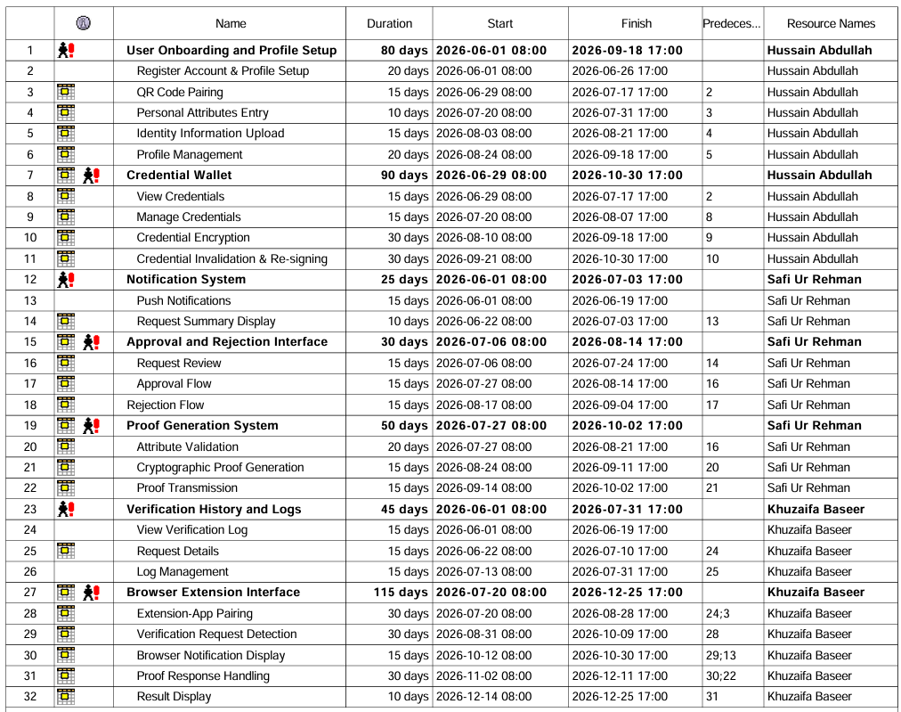
WBS and Gantt Chart
Fig. 13.1 - WBS
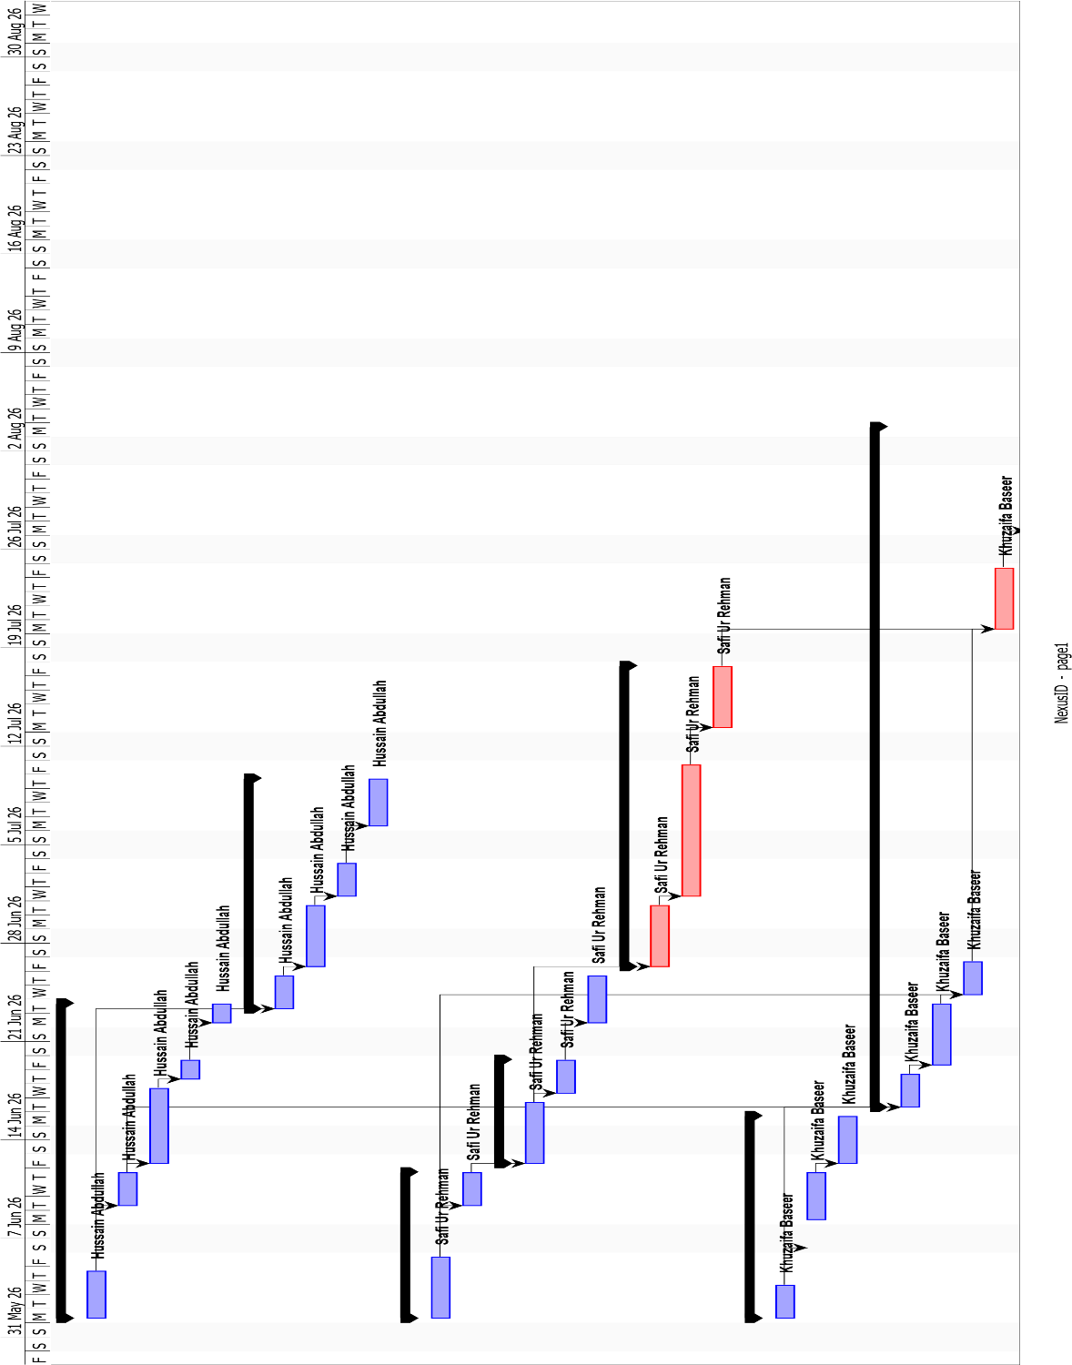

Fig 13.2 - Gantt Chart

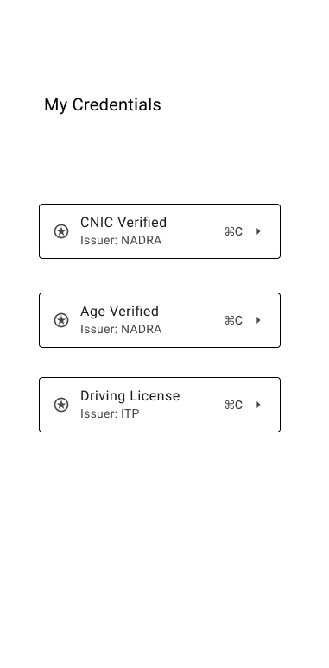
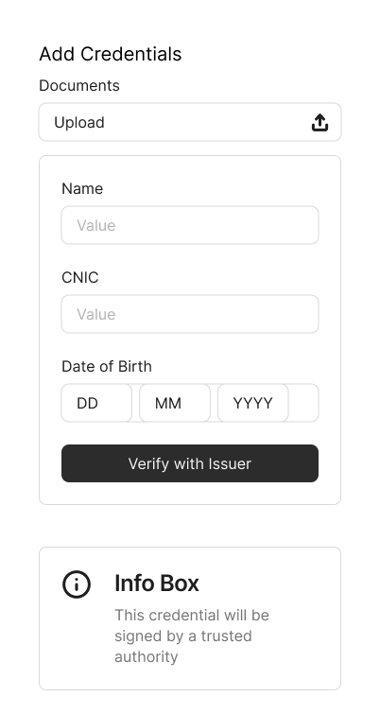
Mockups
Fig 14.2 – View Saved Credentials
Fig 14.1 – Add Credentials

(Fig. 14.1) This screen allows the user to submit their identity details and upload supporting documents to request a verifiable credential. Once submitted, the information is sent to the Mock Issuer for cryptographic signing, after which the signed credential is stored locally in the user’s wallet.
(Fig. 14.2) This screen shows all the verified credentials stored in the user’s local wallet, along with their respective issuers. Each credential entry can be expanded to view its details, giving the user full visibility and control over what is stored on their device.

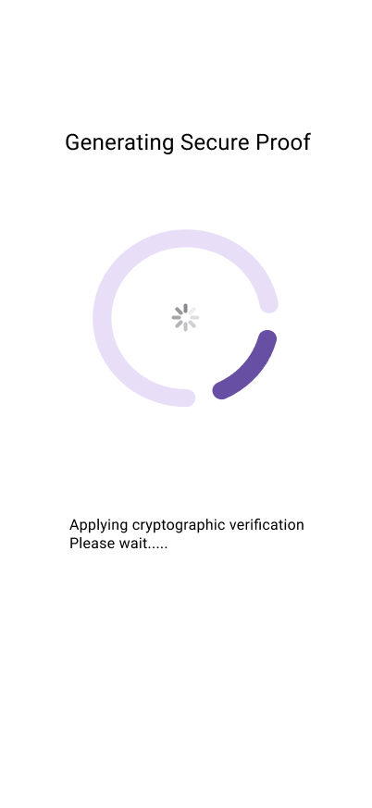
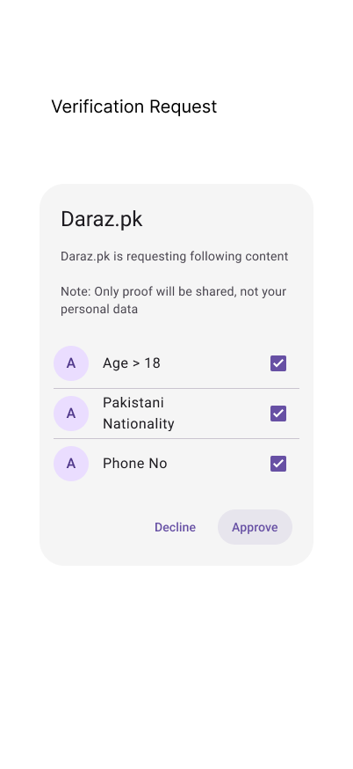
Fig. 14.3 – Incoming Verification Request
Fig. 14.4 – Proof Generation
(Fig. 14.3) This screen displays an incoming verification request from a website, showing exactly which credential attributes are being requested. The user can review each requested field and choose to approve or decline the request before any proof is shared.
(Fig. 14.4) This screen appears when the user approves a verification request. The app applies cryptographic operations in the background to generate a selective disclosure proof, ensuring only the required credential fields are shared with the verifier.

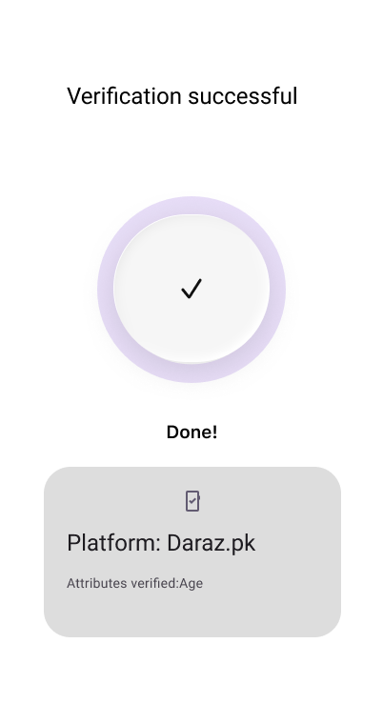
Fig 14.5 – Verification Successful

(Fig. 14.5) This screen confirms that the verification process completed successfully, displaying the platform name and the specific attributes that were verified. It gives the user a clear summary of what was shared, reinforcing transparency after each verification event.

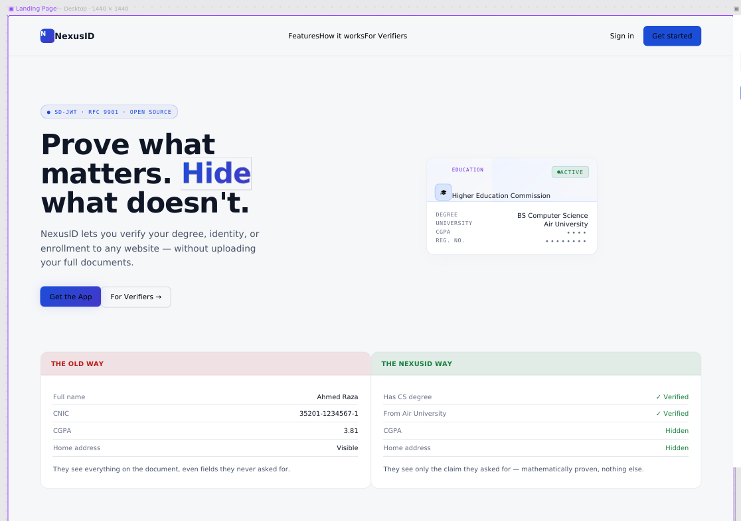
Fig 14.6 – NexusID Web Portal

(Fig. 14.6) This screen shows the NexusID web portal landing page, introducing the platform’s selective disclosure approach. This screen also presents role selection, allowing the visitor to continue as either an End User or a Service Provider.

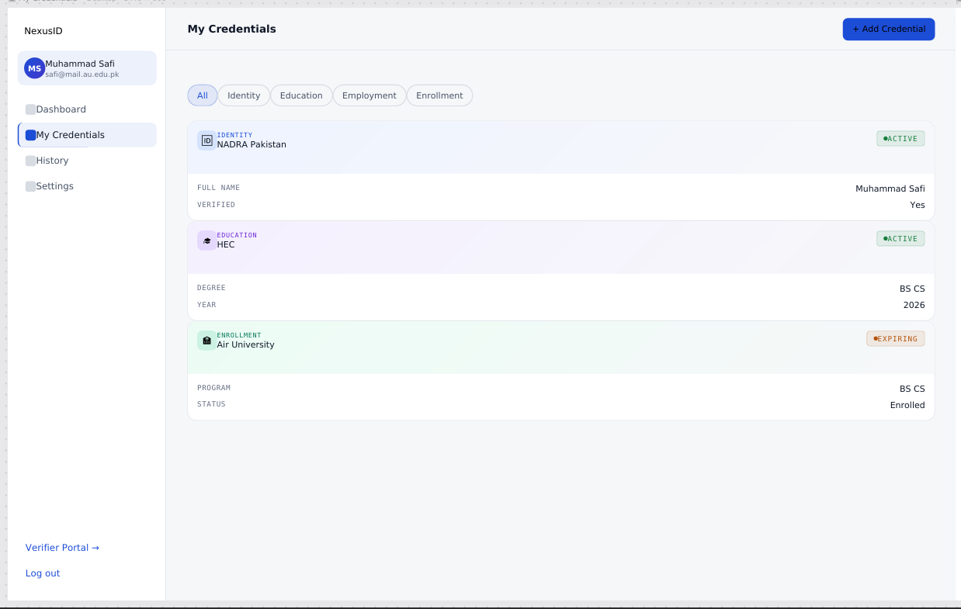
Fig 14.7 – User Credentials Management (Web Portal)

(Fig. 14.7) This screen displays the My Credentials dashboard, listing all credentials issued to the user’s wallet with filtering by attribute type. Each credential card shows its issuer and status.

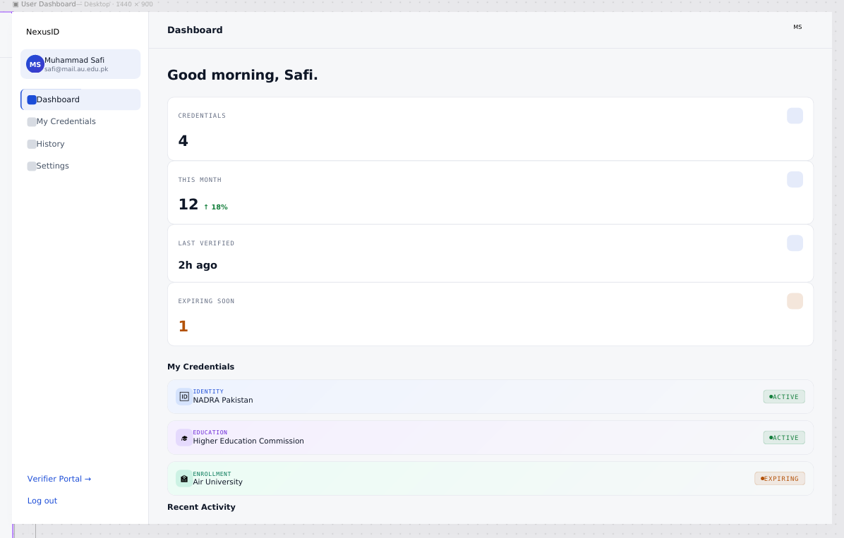
Fig 14.8 – User Dashboard (Web Portal)

(Fig. 14.8) This screen shows the main user dashboard, listing the user’s connected platforms, paired devices, and recent verification history, giving the user an at-a-glance overview of their account and wallet activity.

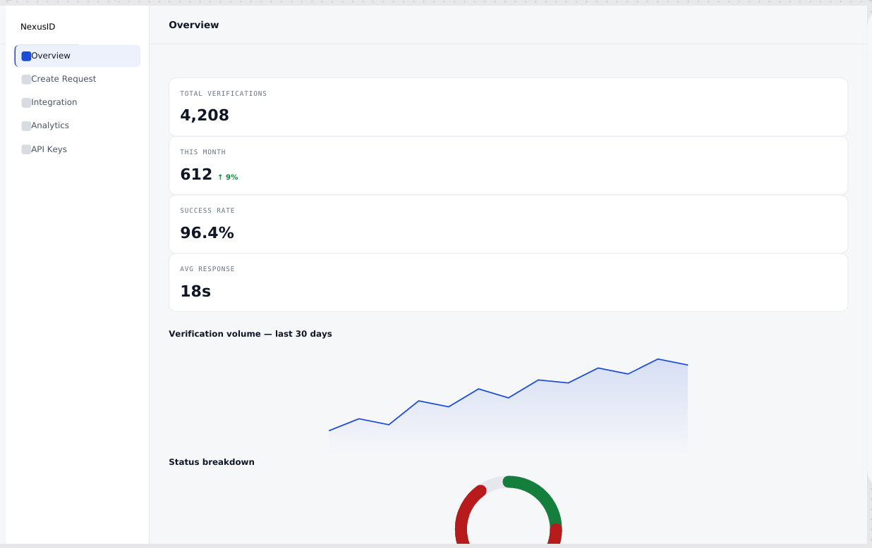

Fig 14.9 – Service Provider Dashboard (Web Portal)

(Fig. 14.9) This screen shows the Service Provider dashboard, displaying a log of verification requests received and an integration code snippet for embedding NexusID verification on the provider’s platform.

References
[1] D. Fett, K. Yasuda, and B. Campbell. “Selective Disclosure for JWTs (SD-JWT), RFC 9901.” Internet: https://datatracker.ietf.org/doc/rfc9901/, Nov. 2025 [Mar. 2026].

[2] M. Sporny, T. Longley, D. Chadwick, and O. Steele. “Verifiable Credentials Data Model v2.0.” Internet: https://www.w3.org/TR/vc-data-model-2.0/, May 2025 [Mar. 2026].

[3] M. Jones, J. Bradley, and N. Sakimura. “JSON Web Token (JWT), RFC 7519.” Internet: https://datatracker.ietf.org/doc/html/rfc7519, May 2015 [Mar. 2026].

[4] National Institute of Standards and Technology. “Secure Hash Standard (SHS), FIPS Publication 180-4.” Internet: https://csrc.nist.gov/publications/detail/fips/180/4/final, Aug. 2015 [Apr. 2026].

[5] Y. Zhu, H. Zheng, B. Qin et al. “Supervised and Revocable Decentralized Identity Privacy Protection Scheme.” Security and Safety, vol. 3, 2024. Internet: https://sands.edpsciences.org/articles/sands/full_html/2024/01/sands20240022/sands20240022.html [Mar. 2026].

[6] Fang et al. “Privacy-Enhanced Distributed Revocable Identity Management Scheme Based Self-Sovereign Identity." Journal of Cloud Computing, vol. 13, no. 154, 2024. Internet: https://link.springer.com/article/10.1186/s13677-024-00715-8 [Mar. 2026].

[7] H. Yuan et al. “A Scalable, Privacy-Preserving Decentralized Identity and Verifiable Data Sharing Framework based on Zero-Knowledge Proofs.” arXiv, Oct. 2025. Internet: https://arxiv.org/abs/2510.09715 [Apr. 2026].

[8] R. A. Pava-Diaz, J. Garcia-Rodriguez, and D. A. Lopez-Sarmiento. “Self-Sovereign Identity on the Blockchain: Contextual Analysis and Quantification of SSI Principles Implementation.” Frontiers in Blockchain, vol. 7, 2024. Internet: https://www.frontiersin.org/journals/blockchain/articles/10.3389/fbloc.2024.1443362/full [Apr. 2026].

[9] O. Terbu, D. Fett, and B. Campbell. “SD-JWT-based Verifiable Credentials (SD-JWT VC).” Internet: https://datatracker.ietf.org/doc/draft-ietf-oauth-sd-jwt-vc/, Feb. 2026 [Mar. 2026].

[10] React Native Documentation. Internet: https://reactnative.dev/docs/libraries, 2025 [Mar. 2026].

[11] Google. “Chrome Extensions Developer Guide.” Internet:
https://developer.chrome.com/docs/extensions/, 2025 [Mar. 2026].

Plagiarism Report
(http://turnitin.com)
